Song Dataset:
- Name: 550K Spotify Songs: Audio, Lyrics & Genres
- URL: https://www.kaggle.com/datasets/serkantysz/550k-spotify-songs-audio-lyrics-and-genres
- Features: danceability, energy, key, loudness, mode, speechiness, acousticness, instrumentalness, liveness, valence, tempo, primary genre, niche genre, year (release year)
- Image:
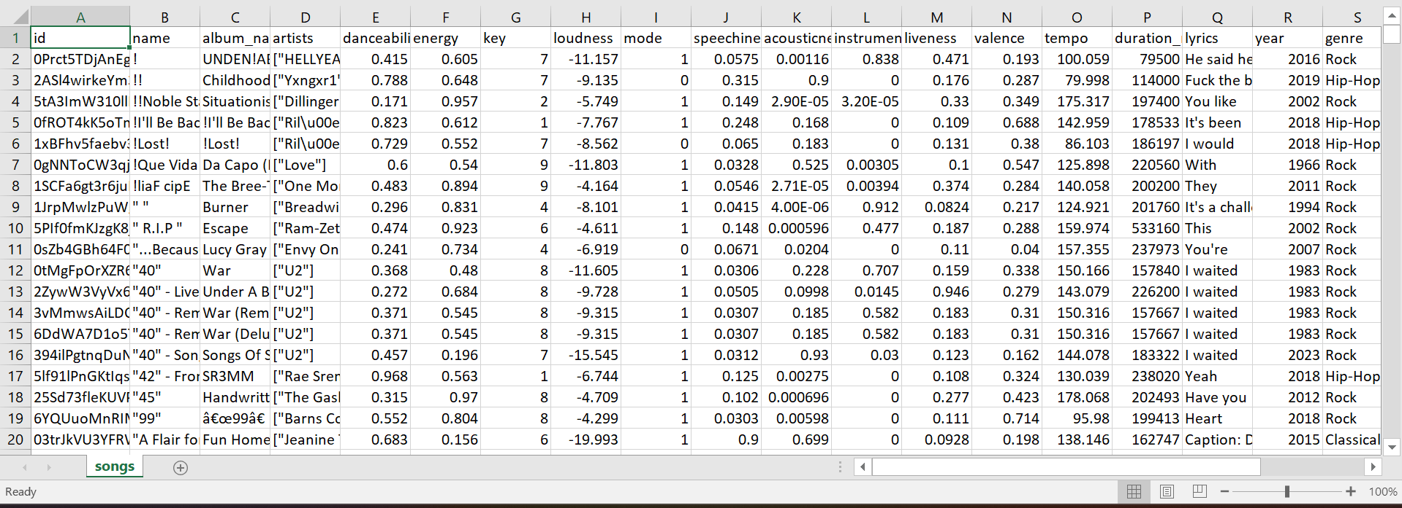

Movie Dataset:
- Name: Movie Lens 32M
- URL: https://grouplens.org/datasets/movielens/32m/
- Features: movieid, year (from the title), genres
- Image:
- 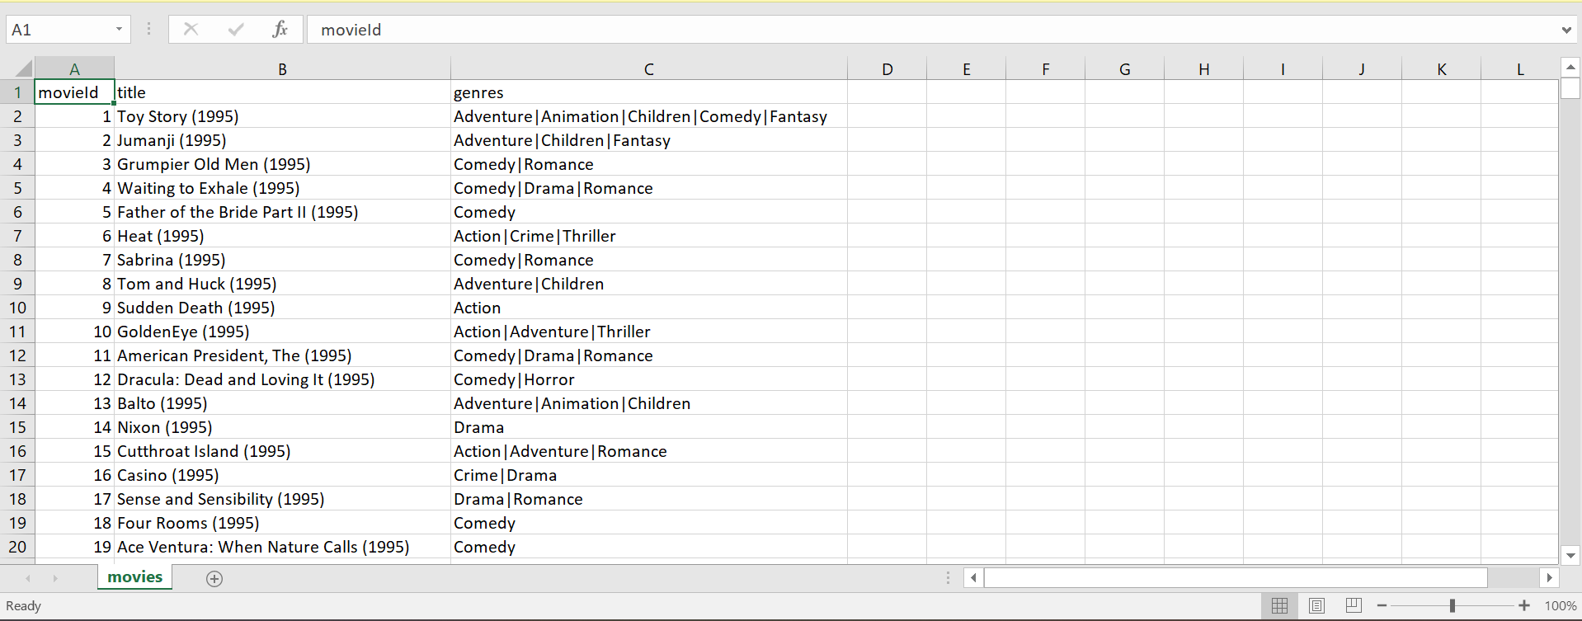
- 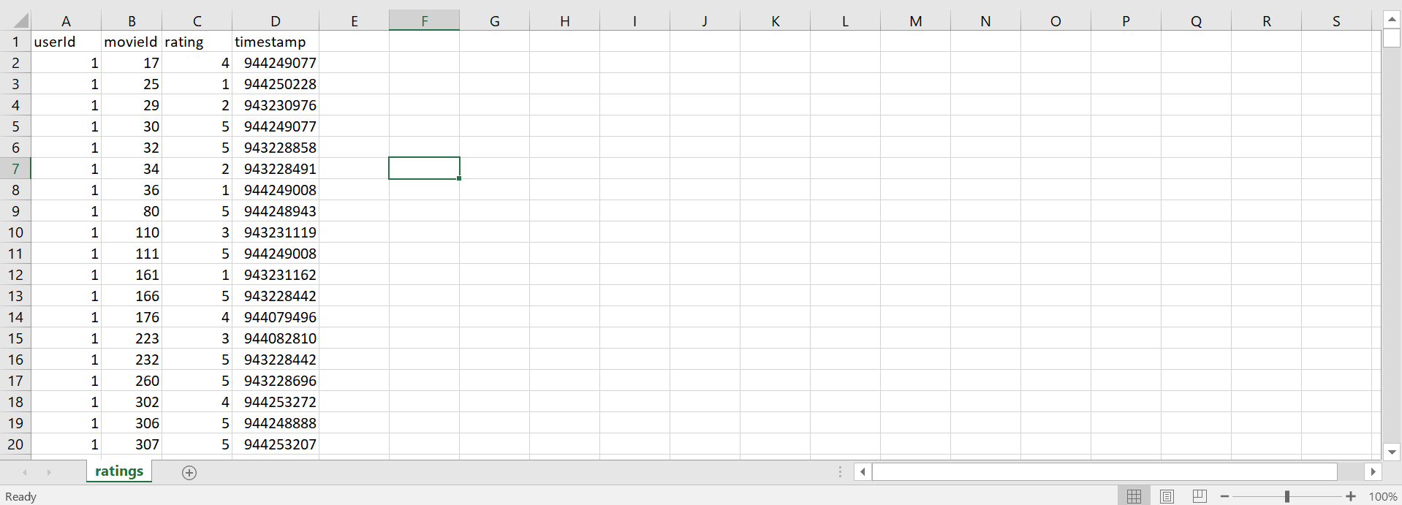

Emotion Recognition:
- Name: Super Emotions Dataset
- URL: https://huggingface.co/datasets/cirimus/super-emotion
- What we used it for: For fine-tuning the distilroberta base model
- Features: Text, Label
- Image:
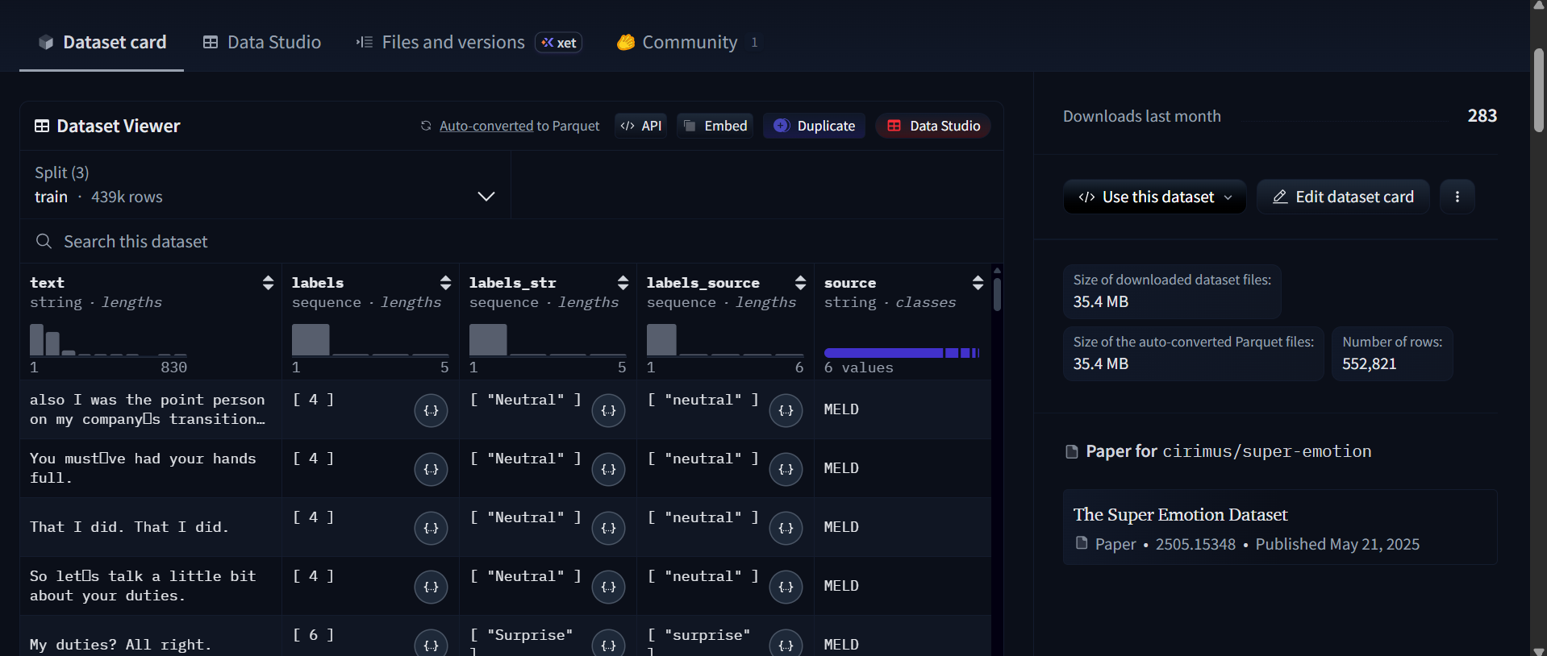

Stress Detection:
- Name: DReddit Dataset
- URL: https://huggingface.co/datasets/asmaab/dreaddit
- What we used it for: Finetuning a Roberta base model
- Features: Text, Label
- Image:
- 